|  |  |  |
| --- | --- | --- |
| 版本R69： | 新增9.3.7Ti/Au-2K/4K規格  新增9.3.9 蒸鍍區使用紀錄表(FM0901155)填寫範例  修改9.3.13轉盤轉速相關作業規定陳述方式 | 發行日20240117 |
| 版本R70： | 新增7.4.6每RUN作業前檢查遮版  修改9.3.12修改E1、E3、E4標準腔溫為75±5℃  新增9.3.13背金作業時轉速為6±2 RPM | 發行日20240401 |
| 版本R71 | 新增4.1中蒸鍍前烤箱使用規範  刪除4.3中TK0121PTN、TKCS16PTS產品於背金蒸鍍清洗前  量測晶背的Ra值  新增5.1蒸鍍前清洗晶片分批作業事項  新增5.2蒸鍍前清洗硫酸說明  刪除原9.3.7晶背Ra值量測內容  新增9.3.7中Al-11KÅ膜厚範圍  新增9.3.7中Ni/Au-2KÅ/10KÅ膜厚範圍  新增9.3.7 Cr/Au (200/800)膜厚範圍’  刪除9.3.8晶背Ra值量測項目  調整9.3.12標準腔溫內容至9.3.13，並新增註明內容 | 發行日20240624 |
| 版本R72 | 新增4.2.10人員確認抽真空時間需控制在1hr以內  新增4.2.12蒸鍍站檔片使用相關說明  修改5.1分批作業說明  新增5.6.1蒸鍍前清洗硫酸作業事項  新增5.6.2硫酸添加說明  新增5.6.7QDR水槽注意事項  新增5.6.8不須烘烤之產品的Q-time作業事項  新增5.6.9需烘烤之產品的Q-time作業事項  新增5.6.10非使用期間腔門須關閉  修改7.2表格文字敘述方式  新增7.2.1靶材長時間未作業處理方式  修改9.3.9紀錄表撰寫內容  刪除 蒸鍍區Ti、Ni、Au紀錄表(MN202111SI06)  新增13.11 1FWF蒸鍍前清洗分批紀錄表 | 發行日20240723 |
| 版本R73 | 新增13.12金屬更換紀錄表  修改7.2表格文字敘述方式(P.16) | 發行日20240731 |
| 版本R74 | 修改4.2.10僅需記錄抽真空時間，E3無提醒則僅需紀錄開始抽  真空時間  修改5.6.7 QDR水槽注意事項更改為不得溢流超過20min  修改9.3.9 第三格欄位不須紀錄片數 | 發行日20240910 |
| 版本R75 | 修改9.2.3內容中E-5檔板至火山口高度須為4cm |  |

1. 目的 Objectives：  
   認識真空區電子槍式真空蒸鍍機及 HF&H2SO4 晶片正背面清洗槽清洗晶片等功能；正確地操作真空區設備，避免造成系統損壞，晶片損失。

To understand the functions of E-Beam Evaporator and functionalities of Chemical Hood to clean wafer by using HF & H2SO4. Operate vacuum area’s equipment correctly to avoid system damage and wafer loss.

1. 相關設備簡介 Introduction of Related Equipments：
   1. 電子槍式真空蒸鍍機 E-Beam Evaporator
   2. 化學處理臺 Chemical Hood
   3. 晶片旋乾機 Spin Dryer (SEMITOOL)
   4. 真空吸筆及鑷子 Vacuum Pen And Tweezers
   5. X10 顯微鏡 X10 Microscope

2.7 氮氣箱N2 BOX

1. 蒸鍍站作業規範大綱 Deposition Station’s Operating Standard Outline：
   1. 蒸鍍站操作流程、步驟及注意事項 (見第4節)

Deposition station’s operating process, steps and attentions. (See Section 4)

* 1. 蒸鍍前(正背面)晶片清洗步驟及注意事項 (見第5節)

The steps and attentions of wafer (front and back side)cleaning before deposition.   
(See Section 5)

* 1. 蒸鍍程式及金屬用量 (見第6節)

Deposition program and amount of metal consumption. (See section 6)

* 1. 蒸鍍金屬Source清洗、預融操作步驟及注意事項(見第7節)

The cleaning and pre-melting operating process and attentions of metallic source of deposition process. (See section 7)

* 1. 蒸鍍站定期維護及測機 (見第8節)

Deposition station’s maintain and test. (See section 8)

1. 蒸鍍站作業流程、操作步驟及注意事項

Deposition Station’s Operating Process, Steps and Attentions：

* 1. 蒸鍍站作業歩驟 Deposition Station’s Operating Steps：
     1. 正面蒸鍍流程 Front side deposition process：

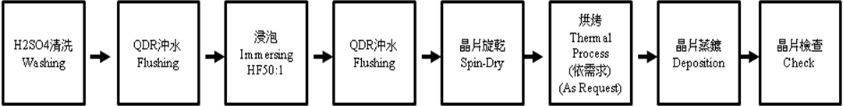(依流程單內容作業為主 Mainly base on Run Card)

* + 1. 背面蒸鍍流程 Backside Deposition Process：

|  |  |  |  |  |  |  |  |  |  |  |
| --- | --- | --- | --- | --- | --- | --- | --- | --- | --- | --- |
| 浸泡Immersing  HF 50:1  or  HF 10:1 背面清洗Backside Washing |  | QDR沖水Flushing+曝氣Aeration +溢流Overflowing |  | 晶片旋乾Spin-Dry |  | 烘烤Thermal Process  (依需求)  (Base on Request) |  | 晶片蒸鍍Deposition |  | 晶片檢查  Check |

(依流程單內容作業為主 Mainly base on Run Card)

* + 1. ZD、T<110μm產品背面蒸鍍流程

ZD、T<110μm Product’s Backside Deposition Process：

|  |  |  |  |  |  |  |  |  |  |  |
| --- | --- | --- | --- | --- | --- | --- | --- | --- | --- | --- |
| 1. 正面鍍Al採浸泡Immerse wafers in HF which have Al plating on front side HF 50:1 2. 正面鍍Ti/Al&Ti/Au採HF 10:1 背面清洗Front side Ti/Al&Ti/Au wafers use HF10:1 to wash backside |  | QDR清洗 Washing+曝氣 Aeration+溢流Overflowing 20min |  | 浸泡Immersing IPA 5min  (手動搖10下Shaking by Hand for 10 Times) |  | 烘烤 Thermal Process 5min |  | 背金蒸鍍Backside Metal Deposition |  | 背金融合Alloy Backside Metal |

(依流程單內容作業為主 Mainly base on Run Card)

* 蒸鍍站請使用F-3或F-5烤箱進行烘烤，正面蒸鍍及背面蒸鍍產品不可同時共用同一個烤箱進行烘烤作業

Please use F-3 or F-5 oven for baking in the evaporation station. Front evaporation and back plating cannot be shared at the same time for baking operations.

* 針對ZD、T<110μm背金清洗有以下兩點特別注意事項：

There have two things particularly needs to be paid attention about ZD、T<110μm backside washing：

1. 正面鍍Al採浸泡HF 50:1時，每片需隔一空格放(13pcs/1 lot)，避免晶片彎曲貼片造成清洗不全

Each wafer, with front side Al plate, needs left a space between the others when put it into the lot (13 pcs/1 lot) to avoid cleaning incomplete because of the wafers is bended.

1. IPA浸泡後1min內需放入烤箱作業，烘烤完從烤箱取出後，需馬上將晶片從烘烤晶舟取出，不可有停滯，以防晶片擠壓造成破片

After dipping IPAwafers must be into the oven within 1min, and wafers must be taken out from boat instantly after it comes out form furnace to prevent the wafers crushed because of squeezing when the thermal process has been completed.

* 1. 蒸鍍機台操作歩驟Operation Steps of Evaporator：
     1. 確定產品片、批號與生產部工作記錄單上記載相符

Confirmed product’s code and Lot number are matched with task record of production department.

* + 1. 將晶片轉入化學處理臺用晶舟。

Put wafers into the boat which is using on chemical process stage.

* + 1. 將晶片作 CR 清洗(依流程單內容作業) QDR。

Take wafers to do CR washing (proceeding as process table)→QDR

* + 1. 清洗完之晶片自 QDR 清洗槽內取出，晶舟H bar必需朝向內，放入晶片旋乾機將晶片旋乾(必需有熱氮及加熱功能)；限用D-14,15,16旋乾機

Take wafers out from QDR washing hood which have been fished washing. The H bar of boat have to face inside, then drying it by spin dryer. (Must have thermal Nitrogen and heat function). D-14,15,16 spin dryer only.

* + 1. 晶片烘烤溫度150±10℃，時間30分鐘(依需求)。  
       Put it into the oven for 150±10℃,30 min.(as request)
    2. 蒸鍍機台破真空 (依照各機台之操作手冊動作)，待 "ATM" 燈亮，即可打開真空蒸鍍室鋼門。

Break vacuum (Follow the equipment operation instruction manual.), then the gate of vacuum chamber can be opened once “ATM” light has turned on.

* + 1. 晶片 Loading：取下卡榫，將轉盤放置桌面承架上；晶片朝上夾入固定位置，利用彈簧固定。將轉盤放入真空蒸鍍室，利用卡榫固定好及補充金屬。

Wafers loading: Take down the letch, and then put rotating disk on the table. Fix the wafer position with it facing up by using spring. Put rotating disk into chamber, and then use letch to fix it and supplement metal source.

* + 1. 蒸鍍機蒸鍍源擋板(shutter)在機台自動蒸鍍時OP人員必需確認Shutter是關閉狀態。

OP staff has to confirm the Shutter is off when the Shutter is proceeding automatically deposition.

* + 1. 執行蒸鍍動作 (依照各機台之操作手冊動作)。

Executing deposition. (Follow each equipment operation instruction manual.)

* + 1. 請人員確認抽真空時間，並將放入腔體時間及開始蒸鍍時間記錄於表單(FM0901155)，E3無提醒則僅需紀錄開始時間

Please confirm that the vacuuming time, and record the time of wafer into the chamber and the time of starting evaporation in the form (FM0901155)，E3 does not have a notice, .it only needs to record the vacuuming start time.

* + 1. 在生產工作記錄單上填入應記錄事項。

Fill in the information on production task record.

* + 1. 可使用報廢產品片用作蒸鍍站的Dummy片使用，但其上方不得殘留金屬，需清洗乾淨保存。

Scrapped product wafer can be used as dummy wafer in the evaporation station, but no any metal should be left on dummy and they need to be cleaned and stored.

蒸鍍站Dummy片請產線將檔片依該鍋產品流程單中的相同的蒸鍍前清洗作業方式進行清洗

Please clean the dummy according to the same pre-evaporation cleaning operation method as that of the run card.

* + 1. 每鍋蒸鍍完，取下Dummy後，請將Dummy上的金屬去除，並確認去除乾淨，或是直接汰除，以利後續蒸鍍作業。

After each pot is evaporated and the Dummy is removed, please remove the metal on the Dummy and confirm that it is completely removed, or directly remove it

* 1. 注意事項 Attentions：
     1. 操作人員在操作電子束機台(E-Gun)執行蒸鍍作業時，必需確定電子束(E-beam)是否為在正中央位置，若否則必需調整電子束於正中央後始可作業。

OP staff must confirm that the E-beam is targeting central position or not when using E-Gun evaporator. It has to adjust to central position before working if it is not at central position.

|  |  |
| --- | --- |
| OK範例圖 | NG範例圖 |
| S:\SI營運中心\研發工程處\工程三部\張智揚\MN，修改OI\改使用電子簽核\未完成(跑電子簽核流程中)\E-gun機台beam點需打在金屬錠中間區域\鋁錠打中間.jpg | S:\SI營運中心\研發工程處\工程三部\張智揚\MN，修改OI\改使用電子簽核\未完成(跑電子簽核流程中)\E-gun機台beam點需打在金屬錠中間區域\鋁錠打歪.JPG |
| 1. Beam點打在金屬錠中間 Beam point are struck in the middle of the metal. | 1. Beam點打偏到金屬錠邊緣靠近坩鍋body。 Beam point deflected to the edge of the metal close to the crucible body. 2. 一樓通知產線作業人員把beam點調整回中間。 1F Notify the production line staff,. 3. 打偏坩鍋body有鍍到鋁需通知設備同仁保養坩鍋body。 Due to the deviation caused by the crucible body has plated to AL need to notify the equipment colleagues to maintain. |

* + 1. 蒸鍍機蒸鍍源(Source)蒸鍍作業時當未使用之Source必需取出，擺放在燒杯中依各金屬之不同分門別類再儲放氮氣櫃中儲存。ex：E-Gun(4)機台中，有四種金屬(Ti Ni Au Al)，當程式設定為(Ti Al)蒸鍍時，則必需從機台上將Ni Au之蒸鍍Source取出，將Ni,Au分別放在2個燒杯中在放入氮氣櫃儲放。

Source must be taken out when it is not using during the process, and put it into a different beacker by different types of metal, and then deposit it into Nitrogen cabinet, e.g. E-Gun(4) have four types of metal(Ti Ni Au Al). The Ni, Au source have to take out when the program is setting for Ti, Al deposition, and place Ni and Au in different beakers before them are deposited in Nitrogen cabinet.

* + 1. 針對E-gun的所有金屬蒸鍍必需先完成金屬預熔後才可以進行蒸鍍工作，避免卡鍋及MAX power。(作業細節見第7節)

All E-Gun deposition have to finish pre-melting before proceeding deposition to avoid disk jammed and MAX power. (operation detail in sector 7)

* + 1. 金屬Slug必須清洗後才可使用(作業細節見第7節)

Slug must be washed before use it. (operation detail in 7 sector)

* + 1. 每個轉盤背面需刻上代號代表哪幾部機台專用轉盤(目前為兩機台共用三組轉盤)，且若未經製程工程及設備工程許可，不可任意更換機台使用。

The back of each rotating disk have to carve a number to present it exclusively using in specific devices. It can’t change to other devices to use without permission of Process or equipment engineer.

* + 1. 操作人員不得任意更改程式，若發現程式不符得立即通知領班與工程確認，程式僅開放該站別工程與設備工程師更改並記錄於蒸鍍程式修改記錄表。

OP staff can not change program arbitrary, and have to inform leader and engineering conformation if find the program is not correct. Program modification only can be accepted by that station’s engineer or equipment engineer, and record it in depositon program modficaion record.

* + 1. 蒸鍍單層或多層金屬膜層時，若中間發生異常(機台、人員…..)，而未蒸鍍完成金屬膜層，不可進行後續補鍍膜層之動作；應開立異常後，逕行去金屬後重工動作，並將異常原因記錄於矽元件蒸鍍機專用表單中，以便於追蹤後續情況。

If the abusual (OP, equipment…etc,) has occurred during single or multiple layer deposition process, and the process doesn’t complete, the layer making up can not be proceed. The situations must be informed, then directly removed the metal and take it to rework. Then record it in the list of Si device evaporator for trace the consequences of it.

* + 1. 每日需保養檢查蒸鍍用氮氣箱並記錄在(FM090306-17)

Please maintain N2 BOX every day and record in (FM090306-17)

* + 1. 3F產品在1F作業及跟鍍背金蒸鍍前清洗時，需依照1F現有的作業方式作業。  
       The 3F wafer cleaning before doing backside metal evaporation in 1F, need to following 1F process.
    2. E-5機台注意事項
       1. 金屬塊底下不需放置鉬墊片。

Molybdenum gasket didn’t should be placed under the metal block

* + - 1. 燈絲更換週期100小時做更換，機台程式中已建提醒設定，使用壽命到達100小時機台螢幕會跳出提示，請產線作業人員看到後通知設備人員做更換。

The filament replacement cycle is 100 hours for replacement. A reminder  
setting has been built in the machine program. When the service life reaches  
100 hours, the machine screen will pop up a reminder. Please notify the equipment personnel to replace it after seeing it.

* + - 1. 每日敲鋁時請設備協助同時以間隙片製具確認燈絲是否有變形情況，若有變形情況提前做燈絲的更換。

When knocking aluminum every day, please use the equipment to help  
confirm whether the filament is deformed. If there is deformation, replace the filament in advanc

* + - 1. 每鍋請產線量測鋁塊重量，監控作業的材料總重量(鋁塊+添加的鋁錠)需達到95±3公克重，作業時仍可參考BOM表添加。

Ex：  
量測鋁塊重量若為79公克，則需添加16公克的鋁錠  
量測鋁塊重量若為85公克，則需添加10公克的鋁錠

Please ask the production line to measure the weight of the Al cone for each pot. The total weight of the materials for the monitoring operation (Al cone + added Al slug) must reach 95±3 g. You can still refer to the BOM table to add it during operation.

* + 1. 轉盤噴砂回廠後的外觀確認如下圖  
       Confirm the appearance of the turntable after sandblasting and returning to the factory, as shown in the figure below  
       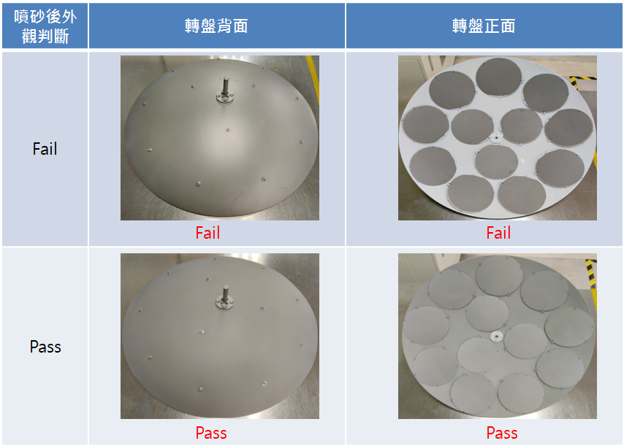

1. 蒸鍍前(正背面)晶片清洗步驟及注意事項 ：

The Steps and Attentions of Wafer (front and back side) Washing before Deposition

* 1. 蒸鍍材料有需分批進行時，需先分批出作業數量後再進行清洗作業，以避免Q-time超出，並將批號記錄於分批清洗表單(FMS10403)中。不得將試片清洗完後放置等待下批作業時才蒸鍍。

When evaporation wafer needs to be carried out in batches, the operating quantities must be produced in batches before cleaning operations are carried out. The tax time will be exceeded, and record the batch number in the batch cleaning form (FMS10403).

The wafer must not be left to wait for the next batch of operations before evaporation after cleaning.

* 1. 於HF清洗前請先以硫酸清洗10分鐘以去除表面有機物

Before HF cleaning, please clean with H2SO4 for 10 minutes to remove organic particle on the wafer surface.

* 1. 浸泡HF 50:1清洗步驟 Washing steps of immerse in HF 50:1：

左槽

* + 1. 若將始用左槽請先按下 的按鍵，如下操作面版。

左槽

Please press the bottom if stat at left side and operating as follow.

手動

* + 1. 將面版按鈕切換到 的位置。

手動

Switch the panel button to position

* + 1. 按下進水閥 按鍵反紅，待水流溢流後才可將晶片放入清洗。

Press the inlet valve button , and then put wafers into it to wash after the water has overflowed.

* + 1. 將晶片泡入槽中必需超過20分鐘(必需有溢流動作)才可將晶片拿出旋乾。

The wafers have to soak into a sink at least 20 min (have to have overflowing)before spin dry.

自動

手動

* + 1. 完成後將 切換成 後即可覆規完成。

手動

自動

Switch to after the process completed.

* 1. 晶片厚度<200μm產品(ZD,T=100μm…)浸泡IPA清洗步驟：

Products, thickness less than 200um(ZD, T=100um), washing steps by immersing in IPA：  
清洗時，需每片空一隔擺放晶片(一個晶舟放置13pcs)，浸泡IPA 5mins並手搖10下，清洗後直接做烘烤。

Each wafer needs left a space between the others (each boat for 13 pcs) when those are washing. Soak it into IPA for 5 mins and shaking it 10 times by hand, and then put it into thermal process directly after washing

.

* 1. 背金前刷洗HF 10:1步驟：  
     Washing steps by using HF 10:1 before backside evaporating：
     1. 將晶片背面朝下放置在充滿HF 10:1之海棉墊上。

Place the wafers on a foam pad which full of HF with backside down.

* + 1. 取出晶片後，作業於QDR槽上方(不可直接在HF10:1清洗盤上方刷洗)，使用海棉棒在晶片背面來回刷洗約四、五次後，將晶片放入注滿水且溢流曝氣中 的QDR槽，直到所有晶片刷洗完成，刷洗時需要刷洗晶片外圍，刷洗時間為60秒。

After taking out the wafer, work above the QDR sink (not allowed to scrub above the HF10:1 cleaning tray)Using sponge stick to brush wafer’s backside for 4,5 times, then place it into QDR sink which is full of water and overflow of aeration until all wafers have been completed washing process, the wafer clean also need to clean of wafer edge, clean time si 60 sec.  
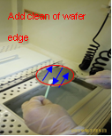

針對特殊產品TY3636PD, ZD, T=100μm等等需每片空一隔擺放晶片於QDR槽中。

For some special products such as TY3636PD, ZD,T=100μm, each of wafer needs leave a space with next in QDR sink.

* + 1. 將刷洗完的晶片放置另一注滿水之QDR槽作自動沖洗後旋乾，另外將原QDR的水排掉也自動沖洗一次後再注滿水，才可進行下一批的作業。

Place the wafers which have been completed previous washing in another QDR sink for automatic flushing, then spin dry it. The water in that sink of QDR has to be drained and automatically flushing before water refilling, then it can stat nest stage of operation.

* 1. 清洗注意事項Attentions for washing：
     1. 硫酸(H2SO4) 使用溫度：110±10℃(加熱器加溫)

Sulfuric acid (H2SO4) operating temperature：120℃(heater Heating)

備註Remark：

第一次使用時，添加400cc的雙氧水，每批添加50cc的雙氧水

The first time, add 400cc of hydrogen peroxide, hydrogen peroxide batch add 50cc

* + 1. 藥水連續泡完2次或雙氧水配完超過30分鐘，如需再使用，則須加200±10cc的雙氧水

After continuous immersion solution twice with hydrogen peroxide or finished more than 30 minutes. To re-use, shall be plus 200 ± 10cc hydrogen peroxide.

* + 1. 背金清洗之IPA槽(4公升)當:

1.每7天

2.每250PCS以上

任一條件時更換乙次並記錄於IPA使用記錄表(FM090171-1)，背金清洗HF 50:1水槽每250PCS更換乙次並紀錄之(FM090171-1)， 背金刷洗HF 10:1紀錄之(FM090171-3)。

The IPA sink, using for backside metal washing (4 liter), needs to replace when it has been used for:

1.every 7 days

2.washed about 250 pcs,

and write it down in the operation record table (FM090171-1). The HF 50:1 sink, using for backside metal washing, needs to replace once when it has been washed about 250 pcs, and record it in (FM090171-1). The HF 10:1, using for backside metal washing, record it in (FM090171-3).

* + 1. 蒸鍍前清洗藥水HF的蝕刻率需要做每日監控，做法如下：

1F以氧化層厚度為7000~9000 Å (F2-1 110IO700) 成長在監控片 (SBL1-3044 R=1~50 ohm-cm)上。

Use furnace tube (F2-1 110IO700) growing oxide layer, thickness=7000~9000 Å,top on control wafer(SBL1-3044 R=1~50 ohm-cm).

各班於換藥水後，蝕刻監控片1分鐘，進行五點量測，將蝕刻率及累積片數記錄於表單 FMS10402並紀錄至SPC表格當中；若當日無配製的清洗藥水則不需特地進行量測。

Every shift all follow : After change HF,let control wafer etching(wash) 1min, then measure 5 points to record etching rate and pcs number on the table  FMS10402, and fill in the SPC form; If unused HF that day, don’t need measurement specially

蒸鍍前清洗HF(50:1)蝕刻率為40~80 Å/min

The HF(50:1) etching rate is 40~80 Å/min

同一清洗槽皆固定重複使用同一監控片以確保數據穩定，若監控片厚度<1500 Å則更換新監控片。   
The same one wash tank use the same control wafer repeated, if the oxide layer

thickness<1500Å, change the new control wafer.

量測前請先校準ST2000，而量測試片五點量測值時以平邊朝上依序為中(1C)、下(2D)、左(3L)、上(4U)、右(5R)，2~5點的位置約為晶片邊緣往內1公分±0.5公分，若量測數據2點以上異常則通知工程

Please calibrate the ST2000 before measurement, and when record table the five-point measurement value is with the flat side toward up in sequence of middle(1C)、down(2D)、left(3L)、up(4U)、right(5R)，2~5 points location at around the edge of the wafer inwards 1cm±0.5cm, If the measurement data is abnormal at more than 2 points, notified the engineer.

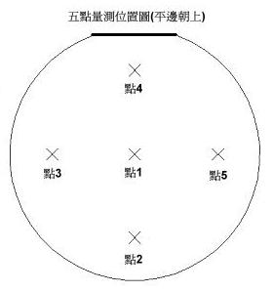

* + 1. 所有蒸鍍清洗用之旋乾機必需有熱氮及加熱功能(限用D-14,15,16旋乾機)，且經清洗後需確認有旋乾及烘乾，無殘留水氣及水痕，若有此現象則需重新清洗。

All the spin dryer which is for washing have to have thermal Nitrogen and heating functions (D-14, 15, 16 spin dryer only). Wafers must be confirmed that is dry and no water vapor or water marks remaining.  
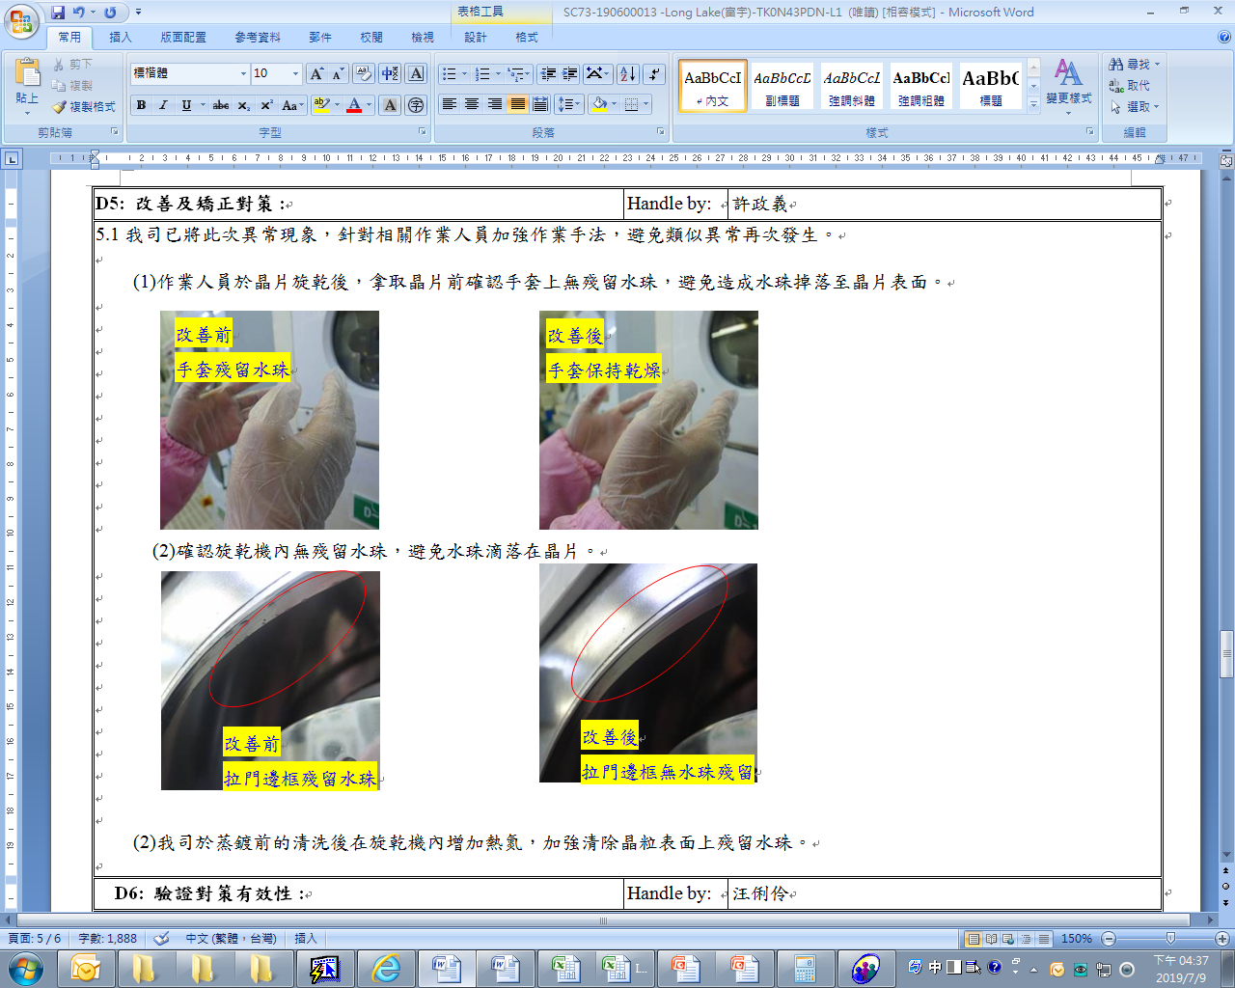

* + 1. 背面晶片清洗必需檢視是否為快速脫水狀態，若不是快速脫水狀態則必需重新清洗乙次，清洗後若還是無法脫水則必需通知領班/組長來確認處理。

Wafer backside washing must be checked that is quickly dehydration status. If not, then it needs washing again. It will have to inform leader/manager if it still can’t dehydration after washing.

* + 1. QDR水槽10分鐘清洗結束後，不得將晶片置於水槽中或持續沖洗超過20分鐘，以免影響後續蒸鍍效果

After the QDR water tank has been cleaned for 10 minutes, The wafer must not be placed in the water tank or rinsed continuously for more than 20 min.

* + 1. 不須烘烤產品晶片清洗完成後，必需要在30分鐘內上蒸鍍作業；不可把已清洗之晶片放在蒸鍍區等候；若逾時超出30分鐘(Q-time)以上，需重新執行清洗製程之作業(N系列PD產品清洗HF50:1 15s)，若連二次逾時則必需開立異常通知工程處理。

Wafer have to start deposition process in 30 min (Q-time) without using an oven after washing. This is not allowed to leave a wafers in deposition area for wait which have been washed. It needs to do washing process again if it already waiting over 30 min.(N series PD products must be cleaned with HF50:1 for 15 seconds) It will have to write down abusual to inform that needs engineering process if the wafer waiting process over 30min twice.

* + 1. 需烘烤的產品晶片清洗完成後必需要在90分鐘內上蒸鍍作業(包含烘烤時間)；不得把以清洗之晶片放在蒸鍍區等候；若逾時超出90分鐘(Q-time)以上，需重新執行清洗製程之作業(N系列PD產品清洗HF50:1 15s)，若連二次逾時則必需開立異常通知工程處理。

Wafers have to start deposition process in 90 min (Q-time) (include thermal process after washing). This is not allowed to leave the wafers in deposition for wait which have been washed. It needs to do washing process again if it has already waiting over 90 min. (N series PD products must be cleaned with HF50:1 for 15 seconds) It will have to write down abusual to inform that needs engineering process if the wafer waiting process over 90min twice.

* + 1. 蒸鍍結束破真空完下完產品片後，請立即將腔門關起以維持腔內潔淨度。非上下鍍鍋及維護、更換耗材(靶材、石英片)期間不得開啟。

After evaporation is completed and the vacuum is broken to remove the product wafers, please close the chamber door immediately to maintain the cleanliness in the chamber. The chamber door must not be opened unless the plating pot is placed or removed and during maintenance and replacement of consumables (targets, crystal chips)

* + 1. 背金蒸鍍”前”須先確認是否有因HF清洗造成正面顏色不均，若有超過晶片面積10%則需開立異常通知；背金蒸鍍”後”必須於4小時內進行背金融合，若逾時則開立異常通知。

It has to make sure that have any discolor on front side due to HF washing “before” backside deposition. It would need to make a notification if discolor area more than 10% of wafer area. The backside metal fusion process has to be proceeded in 4 hours after backside deposition, or it needs to make an abusual notification.

1. 蒸鍍程式及金屬使用量與注意事項   
   Deposition Program, Amount of Metal Usage and Attentions：
   1. 蒸鍍程式及金屬用量等請參照附表。  
      Please check it in reference table.
   2. 蒸鍍過程中若發現鍍率與功率無法達到穩定而不斷震盪時，請通知工程確認。  
      If deposition rate and power can not reach steady state during deposition process, please inform engineering for confirmation.
   3. 人員更換或添加金屬時，一次只能更換或添加一種金屬，避免金屬混料

When operator change or add metal, only one metal can be changed or added at a time

* 1. E-4機台作業鍍含金製程後，每鍋取出金坩鍋量測，量測金坩鍋總重量(金塊+鉬鍋)補足到560±1公克重後再作業下一鍋並記錄在表單(FMS10401)，每次取出金坩鍋做量測前，請人員更換新的手套後再做取出，避免取出金屬時觸碰污染到金屬。  
     After the E-4 machine operates the gold-containing plating process, take out the gold crucible for measurement each time, measure the total weight of the gold crucible   
     (gold nugget + molybdenum pot) and make up to 560±1 grams before starting the operation, and recorded in the form.Before taking the pot for measurement, please replace it with new gloves before taking it out, so as to avoid touching and contaminating the metal when taking it out

1. 蒸鍍金屬Source清洗、預融操作步驟及注意事項：

Washing, Pre-Melting Steps and Attentions of Metal Source( For Deposition)：

* 1. Slug金屬錠清洗**(所有的金屬適用)步驟如下：**The steps of slug ingot washing (suit for all kinds of metal, except Al and Ni)as follow:
     1. IPA浸泡1分鐘(邊泡邊攪拌)

Immerse in IPA for 1 min (with stirring).

* + 1. 烤箱烤30分鐘後即可

Bake in oven for 30min.

* 1. 金屬塊更換時間如下**：**

The replacement time of metal bulk as following：

|  |  |
| --- | --- |
| 金屬  Metal | 更換頻率  Replacement time |
| 鋁  Al | 每30 Run更換，若未達則每週更換  Replace every 30 Run, if not reached, replacement once a week |
| 鋁矽  AlSi | 每15Run更換，若未達則每 3日更換  Replace every 15 Run, if not reached, replacement every 3 days |
| 鎳  Ni | 每30 Run更換，若未達則 每2週更換  Replace every 30 Run, if not reached, replacement every 2 weeks |
| 鈦  Ti | 每30 Run更換，若未達則 每2週更換  Replace every 30 Run, if not reached, replacement every 2 weeks |
| 金  Au | 外觀汙染 則更換，若未達則每個月通知工程確認外觀，每三個月必須更換  Appearance dirty, if not reached, call the engineer check appearance every month,and replace every 3 months. |
| 鉻  Cr | 每10 Run更換，若未達則1週更換  Replace every 10 Run, if not reached, replace once a week |

* + 1. 舊金屬錠由產線回收。

The used metal bulk should be recycled by production staff.

若靶材長時間未作業且已達更換頻率，則回收該靶材，並於下次作業時重新更換為新靶材再進行作業

If the source has not been used for a long time and the replacement frequency has been reached, the source is recycled and replaced with a new one during the next operation.

金屬更換記錄請統一紀錄在金屬更換紀錄表中

Please record all metal exchange records in the metal exchange record form

* 1. 金屬預熔操作方式：(由生產人員操作)

Operation steps of metal pre-melting：(operating by production staff)

* + 1. 確認腔體內不可有晶片。Confirm inside of chamber that has no wafer.
    2. 將所有的面版開關切至Manual(半自動及自動開關和半自動蒸鍍及自動蒸鍍不用切換)。

Change all panel switches to Manual (except semi-auto switch, auto switch, semi-auto evaporator, auto evaporator).

* + 1. 確認機台真空度是否達到Set2設定值。

Check the vacuum level has been reached the setting value of Set2 or not.

* + 1. 將機台Power打開，手調至10%待停留30~60Sec後，再調至20%~30% (由視窗 觀看Slug是否已熔合)。

Turn on the power and adjust it to 10%, and then adjust it to 20~30% after 30~60 Sec (see the slug via window which has been fused or not)

* + 1. 完成預熔後Close power所有開關切至Auto，『Local control box』X-axis and Y-axis Sweep 是否在刻度標示的地方。 1 < Sweep 設定值 < 2

Turn off the Power, and change all switches to Auto when it has completed. Chick 『Local control box』X-axis and Y-axis Sweep is marked at right graduation or not. 1 < Sweep setting < 2

* 1. Source金屬預融及清潔注意事項Pre-Melting and washing attentions of metallic source：
     1. 每次更換新鋁塊及鋁矽塊，第一鍋使用時，須先進行預融，以減少鋁噴濺

When change the new Al cone and new AlSi cone , the first pot must be pre-melted to reduce aluminum splashing.

* + 1. 添加新Slug金屬錠至坩鍋5分滿後，先進行預熔將所有Slug形成塊狀，並經設備或領班確認，再添加Slug金屬錠至9分滿，並於添加金屬後再次預熔使金屬熔平後才可開始作業。

Adding Slug into beaker until half full, pre-melting all slug to become bulk at first, and adding more Slug until 90% full after getting confirmation of equipment engineer or leader. Pre-melting again until it become flat then start to work.

* + 1. 當預融時若發現金屬錠無法完全融合(雜質過多)以及金屬錠表面形狀不平整呈錐形狀有爆金屬的現象應暫停作業通知領班或工程。

The process have to stop if find the ingot can not fuse completely (too much impurity), and the surface of ingot is uneven such as corn shape during pre-melting.

* + 1. 每執行一鍋即進行金屬之添加，若為特殊工程品規格如厚度為50KA，則得先進行預融而非一個RUN加一次金屬。

The Slug needs to add before start running every time. If it is for special case such as 50KÅ, it has to do pre-melting but adding slug per Run.

* + 1. 每個月或200 Run必須由工程確定，是否更換蒸鍍source，並記錄於蒸鍍區作業管理表格。  
       The source should be changed or not every month or 200 Runs needs engineer confirmation, and record it in an “Operation Management of Deposition Table”.
    2. 請人員每RUN作業前檢查遮版開啟時不得遮蔽到二級板斜面上方，以免影響後續產品電性。  
       Please check every run when the shutter opend, should not be blocked above the slope of the secondary board. 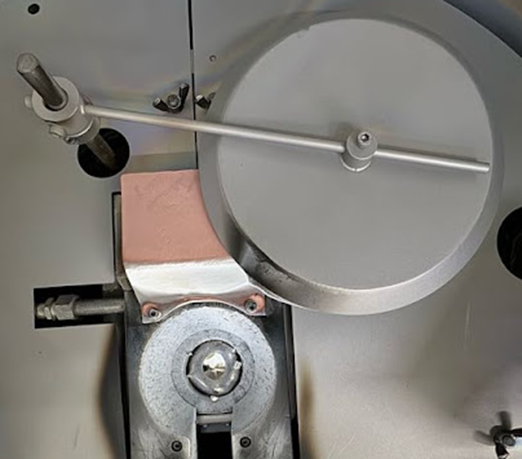

(NG)

* + 1. 執行蒸鍍作業時，於預熔階段需將添加的金屬錠融完，不可殘留金屬錠。

如下圖。

In the pre-melting stage, the metal ingot should be completely melted, and no metal ingot should be left. As picture.  
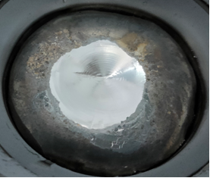 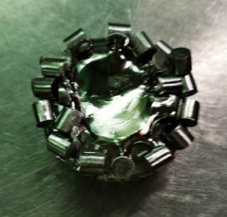  
 OK NG

1. 鋁金屬薄膜之反射率規範與記錄
   1. 若使用ST2000DLXn薄膜厚度量測儀量測，E1、E3、E4、E5鋁蒸鍍之反射率值須大於60%，將其結果記錄於矽元件蒸鍍機生產使用記錄單。

The reflectivity of Alumina film that plated by E1, E2, E3,E5 evaporator must over than 60% if it is measured by ST2000LXn film thickness measuring machine, and record the result in Si device evaporator using record.

1. 真空區定期維護及測機 Vacuum area’s rutting of maintenance and testing：
   1. 生產線操作人員定期工作內容 Rutting task of production line operator：
      1. 每天檢查 HF 50:1 清洗槽，H2SO4 清洗槽，不足立即補充。

Check HF 50:1 sink and H2SO4 sink every day, and refill it if it’s not full.

* + 1. 每週至少擦拭機臺及四周工作區域壹次。

Wipe a machine and area around it at least one time every week.

* + 1. 遇晶片轉盤或襯板沉積過量金屬時(已有金屬剝落跡象)，務必用刀片刮除

When wafer rotating disk and liner plat has accumulated over amount of metal, it has to be washed by using curettage.

* + 1. 紀錄機台顯示的”石英震盪片可使用率(%)”於蒸鍍工作紀錄單之備註欄位，若蒸鍍後剩餘值<15%(E-Gun 3<4.4MHz)，則需馬上更換。

The “availability rate of Quartz Crystal Resonator (%)” that recorder shows needs to record in reference column of Si device evaporator management record. It has to be replaced if remain rate less than 15% after deposition(E-Gun 3<4.4MHz).

* + 1. 冷凍pump每月作"再生"動作一次(記錄於蒸鍍區作業管理表格)。

To “Regenerate” freezing pump once a month. (record it in Si device evaporator using record)

* + 1. 更換石英震盪片後第一鍋皆需作膜厚量測並記錄 。 (記錄於蒸鍍區更換石英震盪片，矽元件蒸鍍機生產使用記錄表)

The thickness measurement of first run needs to be down and recoded after Quartz Crystal Resonator has been replaced (record it in Quartz Crystal Resonator replacement table and Si device evaporator using record)

* + 1. 蒸鍍用轉盤(作業鋁)若該轉盤當周作業次數小於5鍋，則不需噴砂，否則每週至少噴砂一次，而蒸鍍用轉盤(作業金)每月至少噴砂一次(記錄於蒸鍍區作業管理表格)。

If the rotating disk(for Al) operates less than 5 pots per week, sand blasting is not required, Otherwise needs to do send blasting at least one time a week

A rotating disk(for Au) needs to do send blasting at least one time a month (record it in Si device evaporator using record).

* + 1. 蒸鍍機台E-Gun(1) ~ E-Gun(5)每15±2鍋清理坩鍋，若夜班作業超過清理鍋數時延至早班做清理(可超過≦3鍋)、Shutter並使用吸塵器清潔腔體內襯及轉盤軌道，並記錄(FM0901155)，若有>15±2鍋要延後清潔需求，需告知領班確認。

All the evaporators such as E-Gun(1)~E-Gun(5) have to clean gunbody and shutter per 8~10 runs, If it is exceeded during night shift, it will be extended to the morning shift for cleaning(≦3 runs)、 and use vacuum to clean lining of chamber and orbit of rotating disk,and record (FM0901155). If there is a need to postpone the cleaning operation for >10 runs, the leader must be notified.

* + 1. 背金清洗用之藥水HF(10:1)、12吋濾紙及擦拭棒每班至少更換一次，如有髒汙、破洞應立即更換(避免毛絮沾上晶片)，背金清洗用海綿應每個月更換，並記錄(FM090171-3)

HF(10:1) and 12 inches filter and swap which are for backside metal washing has to change at least once a shift. It must be replaced immediately if there have dirty and a hole on it,and record(FM090171-3).

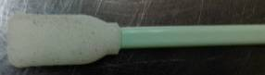

髒汙

* + 1. 金屬Slug使用前清洗及鋁塊定期清潔(清洗方式如第7節說明內容)  
       Slug washing regularly and before use (follow 7 sector to wash)
    2. 蒸鍍機更換襯板至每個月告知設備更換 (130Run提前告知)

Equipment engineer needs to be informed in advance that get ready to replace liner plate every month (inform in advance at 130 Run).

* + 1. 晶片盒須緊密蓋緊，避免晶片受到外部環境粉塵污染，以及傳送過程中掉片與破片的發生。

Wafer case must be sealed tightly to prevent the wafer be contaminated by particles which is from outside, also drop and broken during transportation.

* + 1. 帶有光阻材料進蒸鍍機需專機專用，不可與正常品一起作業，切換金屬時需空鍍鋁，才可後續作業。

With photoresist product deposited into the machine should designate, can not work with normal product.When switch the deposited mateerial ,need to deposit aluminum,than can work next run.

* 1. 設備定期保養工作內容 Equipment regularly maintain：
     1. E-Gun(2)之內襯須在30±5天實行更換；E-Gun(1)(3)(4)(5)每200±20 Run 作更換。

A lining of E-Gun(2) have to be replaced at 30±5 days, E-Gun (1)(3)(4)(5)needs to replace it every 200±20 runs.

* + 1. 每次機台保養後需做真空度校正、腔溫校正、轉盤刻號確認、軌道及轉盤軸心匹配確認。  
       Equipment needs to do vacuum degree and temperature calibration, number rotating disk and axis of rotating disk and orbit matched confirmation.
    2. 確認各機台的SHUTTER 至二極板的距離 <6mm(圖一)及SHUTTER到火山口的左右兩邊高度差<3mm(圖二)以避免遮板歪斜，E-5沒二極板構造設計，改為前、左、右三邊SHUTTER到火山口高度為4CM且三邊高度差<3mm(圖三)。

To make sure the distance between Shutter and plate of diode is <6mm. The height difference between the left and right side of Shutter is less than 0.3mm to avoid skew For E-5, the height from the front, left and right sides of the SHUTTER to the hearth deck is 4CM and the height difference between the three sides is less than 3mm

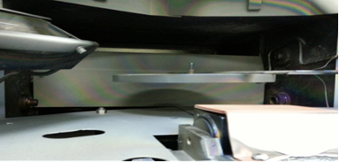

SHUTTER

二極板

圖一

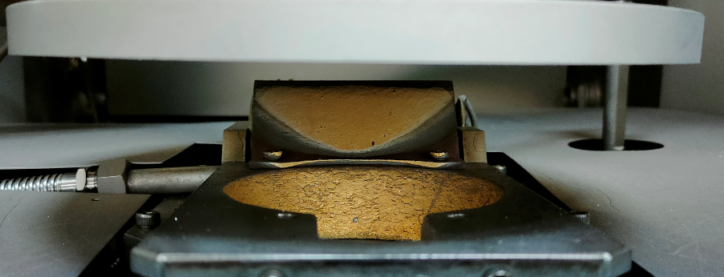

左邊

右邊

SHUTTER

圖二

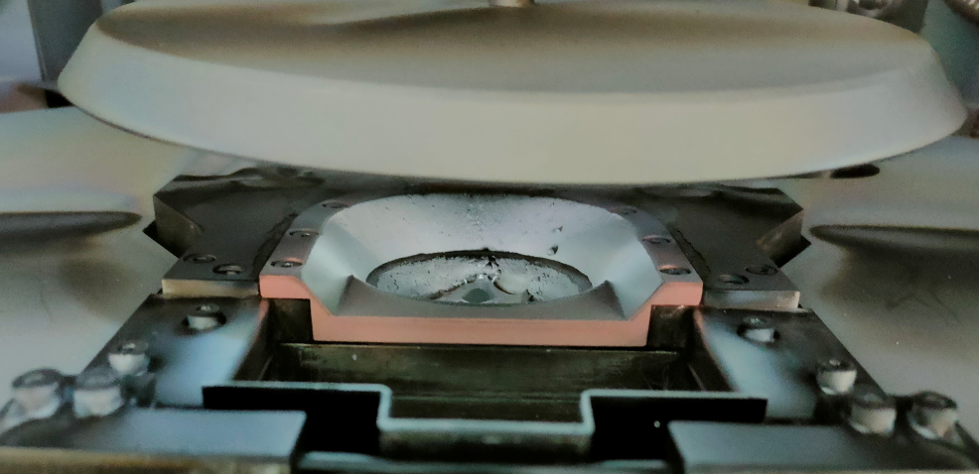

SHUTTER

前邊

左邊

右邊

圖三

* 1. 鍍膜定期校驗、機台腔體溫度校驗內容及機台轉速設定：  
     Thickness regularly and chamber temperature inspection condition and rotating speed setting:
     1. 鍍鋁製程須每RUN以載玻片放入蒸鍍機中同蒸鍍，不論膜厚，除原本監測的載玻片外，額外在鍍鍋外圈黏貼一片預先裁切好大小的載玻片(如圖四)，並將內、外圈的膜厚量測數據紀錄於蒸鍍區使用記錄表及SPC表格中。

When every evaporating Al, in addition to the monitoring glass slide center ring, an additional piece of glass slide is attached to the outer ring of the plating pot, and record the film thickness of center and outer rings, on the table and SPC sheet.

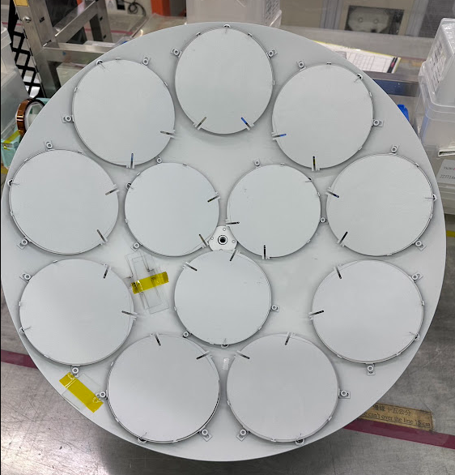

圖四

* + 1. 紀錄膜厚時，請分別量測載玻片的左上點及右下點(如圖五)，內外圈載玻片共4點。

When recording the film thickness, please measure the upper left point and the lower right point of the glass slide respectively, totally of 4 points on the center and outer ring slides.

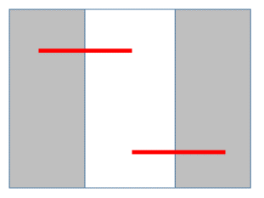

圖五

* + 1. 作業時請將內外圈膜厚及該批鍍鍋內圈的晶片號紀錄在RUN card上正面金屬蒸鍍後方的空白區域中，而蒸鍍區作業紀錄表上僅需記錄內外圈膜厚共四點即可。

Please record the center and outer ring thickness and the center ring wafer number to the blank area behind the metal evaporation on the front side of the RUN card, and the Evaporation record sheet only need record the center and outer ring thickness at four points.

紀錄方式如下，其中O表示外圈，C表示內圈：

The record pattern is as follows, “O” means the outer ring and“C” means the center ring:  
RUN CARD：  
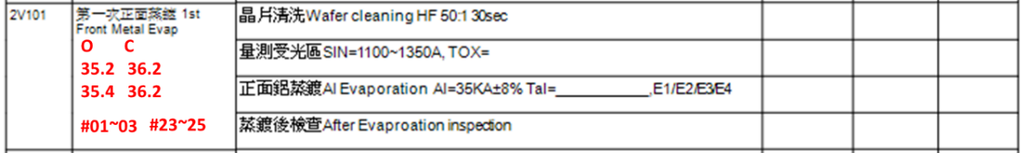

* + 1. 請產線作業人員在發現膜厚超出製程規格時，將該鍋內外圈載玻片的背面寫上作業機台、日期時間、量測膜厚數據後，將載玻片放入夾鏈袋後保留，並放至於工程異常桌上，以利工程複檢。

When thickness out of process range, write the machine number, date, start time, and thickness data on the back of the glass,then placed in a zipper bag, kept and placed on the engineer abnormality table for re-inspection.

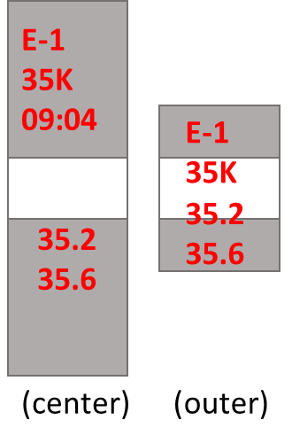

* + 1. 背鍍Cr /Au需每RUN放載玻片並量測該厚度，並檢查載玻片顏色是否如圖中所示。  
       evaporate Cr/Au need put a glass and measure the thickness every run, and check the color of the glass is the same as in the figure.

背鍍 Au：

Backside metal Au：  
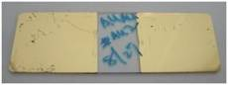 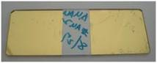

載玻片正面 front-side 載玻片背面 back-side

背鍍 Cr / Au：

Backside metal Cr / Au：

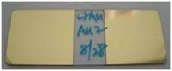 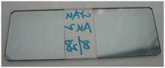

載玻片正面 front-side 載玻片背面 back-side

* + 1. 每鍋蒸鍍後需試刮背金2片確認是否有脫金現象，限晶片厚度300um以上。Scratch test backside metal 2pcs/run after evaporation to check that does au peeling or not,only wafer thickness ≧300um.
    2. Thermal1&2背鍍Au/Au及AuAs/Au其厚度需大於其相加的最小厚度即可。Thermal1&2 backsidemetal thickness of Au/Au&AuAs/Au ≧total thickness.

|  |  |
| --- | --- |
| 膜厚範圍  Thickness Range | 誤差值  Error Tolarence |
| Al-11KÅ | ±3KÅ |
| Al-28KÅ | ±3KÅ |
| Al-35KÅ | ±5KÅ |
| AlSi-28KÅ | ±3KÅ |
| AlSi-35KÅ | ±5KÅ |
| Al/Ni/Au-10KÅ/5KÅ/2KÅ | ±3KÅ |
| Ni/Au-2KÅ/10KÅ | ±3KÅ |
| Ti/Al-0.5KÅ/9.5KÅ | ±2KÅ |
| Ti/Al-2KÅ/35KÅ | ±3KÅ |
| Ti/Al-3KÅ/35KÅ | ±3KÅ |
| Au/Au-1.5KÅ/1.5KÅ | ±0.3K**Å** |
| AuAs/Au-1.5KÅ/1.5KÅ | ±0.3K**Å** |
| AuAs/Au-1.5KÅ/2.5KÅ | ±0.4K**Å** |
| Ti/Au-3K/12K | ±1.2 K**Å** |
| Ti/Au-2K/4K | ±1.2 K**Å** |
| Ti/Ni/Au-10K/5K/2K | ±3KÅ |

* Cr/Au (200/600)：總厚度規格為720Å~1600Å
* Cr/Au (200/800)：總厚度規格為820Å~1600Å
* Cr_穿透率%< 10% 才是合格，若二項有一項未達到為異常，即時通知領班／組長處理。

The backsidemetal thickness of Cr/Au should be 720Å~1600Å and the transmittance of Cr should be < 10%. If the two items have not reached an exception, please inform leader or supervisor to handle it.

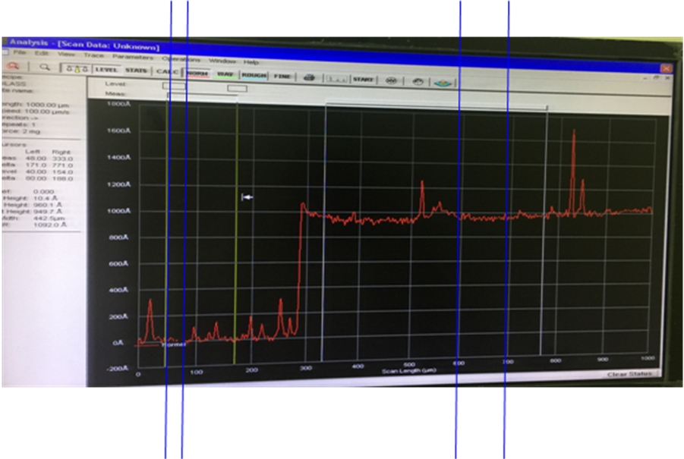

如上圖，取樣方式也盡量取平坦區域做量測

Try to take a flat area for measurement

* + 1. SPC抽樣方式如下，量測值應在SPC製程及管制範圍界線以內，如有異常，  
       即時通知領班/組長處理。  
       The SPC sampling as chart,the measurement value should be in SPCprocess limit and control limit, please inform leader or supervisor if it is not.

|  |  |  |  |  |  |
| --- | --- | --- | --- | --- | --- |
| **蒸鍍機台** | **材料** | **規格** | **單位** | **取樣方式** | **取樣週期** |
| E-1 | Al | 28K | Å | 4Point/2Glass/Run | 每鍋 |
| E-1 | Al | 35K | Å | 4Point/2Glass/Run | 每鍋 |
| E-1 | AlSi | 35K | Å | 4Point/2Glass/Run | 每鍋 |
| E1 | TI/Al | 2K/35K | Å | 4Point/2Glass/Run | 每鍋 |
| E1 | TI/Al | 3K/35K | Å | 4Point/2Glass/Run | 每鍋 |
| E-2 | Cr/Au | 200/600 | Å | 4Point/1Glass/Weekly | 1鍋/每週不定時量測一次 |
| E-2 | Cr_穿透率% | <10% | % | 2Point/1glass/day | 第1Run/每day，蝕刻Au後，量測 Cr＿穿透率% |
| E-3 | Al | 28K | Å | 4Point/2Glass/Run | 每鍋 |
| E-3 | Al | 35K | Å | 4Point/2Glass/Run | 每鍋 |
| E-3 | AlSi | 35K | Å | 4Point/2Glass/Run | 每鍋 |
| E-4 | Al | 28K | Å | 4Point/2Glass/Run | 每鍋 |
| E-4 | Al | 35K | Å | 4Point/2Glass/Run | 每鍋 |
| E-4 | AlSi | 35K | Å | 4Point/2Glass/Run | 每鍋 |
| E-4 | TI/Au | 3K/12K | Å | 4Point/2Glass/Run | 每鍋 |
| E-5 | Al | 28K | Å | 4Point/2Glass/Run | 每鍋 |
| E-5 | Al | 35K | Å | 4Point/2Glass/Run | 每鍋 |
| E-5 | AlSi | 35K | Å | 4Point/2Glass/Run | 每鍋 |

* + 1. 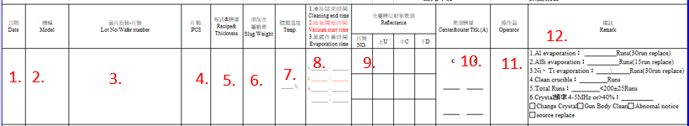蒸鍍區使用紀錄表填寫：

紀錄內容分別為The recorded contents are：  
1.日期、2.機種、3.晶片批號、4.片數、5.程式&膜厚、6.添加金屬重量、7.腔體溫度、8.(1)蒸鍍前清洗結束時間、(2)抽真空開始及(3)機台作業時間、9.抽測片號及反射率、10.內外圈各2點膜厚量測、11.操作員簽名、12.(1)Al作業鍋數、(2)AlSi作業鍋數、(3)Ni、Ti作業鍋數、(4)清腔體累計鍋數、(5)總作業鍋數、(6)石英片數據、更換石英片、清腔體確認、開立異常單、更換金屬靶材。

1. Date, 2. model, 3. Wafer batch number-piece number, 4. Number of pieces, 5. Recipe & film thickness, 6. Added metal weight, 7. Chamber temperature, 8. (1) Evaporation completion cleaning End time, (2) start of evacuation and (3) machine operation time, 9. Random test of piece number and reflectivity, 10. thickness measurement at 2 points in each run, 11. Operator signature, 12. (1) Al Number of operating runs, (2) Number of AlSi operating runs, (3) Number of Ni and Ti operating runs, (4) Cumulative number of cleaning chamber, (5) Total number of operating runs, (6) Crystal information, replacement Crystal , Confirm chamber cleaning, Abnomal notice, and replace metal source.  
   * 1. SPC開立異常標準：

Principle of abnormal reflectivity SPC determination:

1點超出管制界限外則需開立SPC異常

If 1 points exceed SPC control limition (x-bar),need to write down abnormal card.  
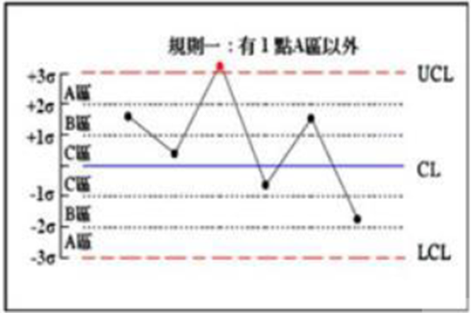  
組內數據最大值及最小值的差值R>2.5

Between the max value and the min value of the data in the group is R>2.5

* + 1. 下列管制條件不須開立SPC異常：

The fallowing control conditions does not need to write down SPC abnormal card:  
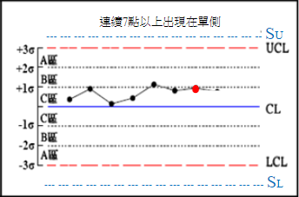

連續7點以上在單側不須開立異常

7 consecutive points on one side does not need to write down SPC abnormal card.

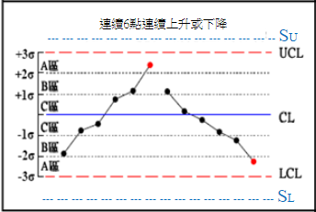

連續14點交互上升或下降不須開立異常

14 consecutive points of interactive increase or decrease does not need to write down SPC abnormal card.



連續六點上升或下降不需開立異常

6 consecutive points of increase or decrease does not need to write down SPC abnormal card.

若蒸鍍膜厚超出管制界限，則僅需開立SPC異常表單，倘若蒸鍍膜厚超出製程規格，則除了開立SPC異常表單外，亦須開立產品異常，並將該批產品交由蒸鍍站工程師確認，且保留該鍋載玻片，並置於異常桌，待工程複檢。

If the thickness exceeds the control range, that only need to write the SPC abnormal notice.

If the thickness exceeds the process specification, in addition to writing an SPC abnormal notice, a product abnormal notice must also need to writed, the batch of wafer will be handed to Engineer confirmed,then keep the pot of glass in a zipper bag and put on engineer abnormal table for re-inspected.

若量測數據有異常，請開立異常通知單後，再通知蒸鍍站工程師確認。

If any abnormality with the measurement data, please write the abnormal notice then notify the engineer.

* + 1. 每次機台及有更換內襯時，機台需作腔體校溫乙次。

Equipment needs to calibrate chamber temperature when the lining has been replaced.

* + 1. 腔體溫度校正需使用溫度規，置放於腔體內轉盤蒸度表面上。  
       Chamber temperature needs to use temperature gauge calibration and put it inside of chamber and on the top of rotating disk

|  |  |  |  |  |  |
| --- | --- | --- | --- | --- | --- |
| 機台編號  Number of Evaporator | E-Gun(4) | E-Gun(3) | E-Gun(2) | E-Gun(1) | E-Gun(5) |
| 標準腔溫  Temperature Standar | 75±5℃ | 75±5℃ | 100±5℃ | 75±5℃ | 75±5℃ |

若流程單上未特別註明，則依上述表格標準腔溫進行作業

註：1.鍍Ni/Au產品蒸鍍溫度為180±5℃(包含佳邦產品)

2.機台實際溫度會因蒸鍍作業略高於設定溫度為正常現象

* + 1. 一般產品轉盤轉速須調整為11 ±2 RPM。  
       All the rotation speed is 11 rpm±2 RPM.

而當When：

1. 背金作業時

Back metal evaporation

1. E-4蒸鍍N系列產品  
   N series PD in E-4
2. 使用E-5機台作業  
   Working on E-5
3. 晶片厚度≦150um時，  
   Wafer thickness≦150um

須將轉盤轉速調整為6±2 RPM。  
Rotating speed is 6±2 RPM.

當不同作業轉速的產品共批作業時，轉速以低轉速產品為主。  
When products with different rotation speeds are operated in a batch, the rotation speed should be dominated by low-speed products.

轉速數值觀察螢幕面板顯示值，無螢幕的舊機台則觀察機台實際轉速。.

The value is based on the display value of the screen panel.The old machine is based on the actual speed.

* + 1. 紀錄機台操作起訖時間 ，開始抽面板顯示”粗抽”時間為起，面板顯示”結束”為訖。  
       Record the operation time of machine from rough vacuum to end.
    2. 確認不同蒸鍍材料於蒸鍍時的真空值。  
       Make sure the value of vacumm when the material is different.

|  |  |  |
| --- | --- | --- |
| 正背金  Front and Back | 蒸鍍材料  Material and Layer | 真空值  Vacumm Value |
| 正 Front | Ti / Al | 3.5×10-4Pa |
| 正 Front | Al | 3.5×10-4Pa |
| 正 Front | AlSi | 3.5×10-4Pa |
| 正 Front | Ni / Au | 1.4×10-4Pa |
| 正 Front | Al / Ni / Au | 1.4×10-4Pa |
| 背 Back | Ti / Au | 1.4×10-4Pa |
| 背 Back | Au | 3.5×10-4Pa |
| 背 Back | Al / Ni / Au | 1.4×10-4Pa |
| 背 Back | Al / Ti / Ni / Au | 1.4×10-4Pa |
| 背 Back | Cr / Au | 1.4×10-4Pa |

* + 1. Tooling function：

Tooling(未來設定值) Apha-step/SEM(實際儀器量測值) tooling(原本的實際值)%

(Futrure) = Meter(機台顯示值) × (Original)

* + 1. 再生操作(實際操作動作須已機台上所標示或機台說明書為準)：  
       Regeneration operation (following User Guide to operate)
    2. 非自動機台再生操作 Regeneration operation of manual equipment.
    3. 機台破真空。Vacuum breaking.
    4. “N2(In)””N2(out)”按下燈亮等一小時後，按下”N2(IN)””N2(OUT)”燈滅。  
       Push “N2(In)””N2(out)” to light on for an hour, then push it again to light off.
    5. 按下””MBP””MECH.PUMP”燈亮；機檯開始自動再生冷凍真空PUMP動作。  
       Push ””MBP””MECH.PUMP” to light on. Active automatically freezing vacuum regeneration pump.
    6. 一小時後”READY””HI-VAC PUMP”燈亮即完成再生動作。  
       Once ”READY””HI-VAC PUMP” light on after one hour, regeneration has been  
       completed.
    7. 動機台再生操作 Regeneration operation of freezing equipment：
       1. 再生 -> 開始 待完成訊號 ->結束。  
          Regeneration → start, waiting completed signal → finish.
       2. 暖機 -> 開始。 Warm up →start.

1. 生產線異常及緊急處理程序 Abusual of production line and emergency treatment procedure：
   1. 一般機台異常處理(遇下列任一情形，立即通知領班/組長確認)：  
      Regular equipment abusual treatment (inform supervisor/ leader to confirm immediately when encounter any situation as follow):
      1. 機臺 alarm 響起(例如：蒸鍍機卡鍋、Max power…等 )。  
         An alarm of equipment starts to ring (e.g. evaporator rotating disk jamming, Max power, etc.)
      2. 化學處理臺之加溫槽溫度異常。  
         The temperature abusual of heating sink of chemical processing stage has occurred.
      3. 鋁35K總作業時間超過三小時且連續三Run時，通知設備確認機台。  
         When the Al(35K) working for more than three hours and three consecutive runs, notify the equipment personnel to confirm the machine.
   2. 停電時之異常處理 Abusual treatment when power failure occurred：
      1. 確認機台Chember是否為『真空狀態』，若不是為真空狀態時，則需取出晶片並依流程單分類放入氮氣櫃內存放待工程確認。  
         Confirm the equipment is “vacuum status” or not, take out the wafers and place it in Nitrogen cabinet with different categories by following process table for engineering conformation if it’s not.
      2. 蒸鍍未完成發生停電當機時，該鍋之晶片需依流程單分類後，開立異常單待工程處理。  
         When power failure has occurred during deposition process, which those wafers have to be separated to different categories by following process table, and write down abusual notification for waiting engineering processing.
      3. 若已清洗且待蒸鍍之晶片，則待機台回復後需做重新清洗動作。  
         The wafers, has been washed and waiting for plating, needs to do washing again after equipment back on line.
2. 自主檢驗項目及規範 Self-Inspection Category and Standard：
   1. 自主檢驗項目 Self-Inspection Category

| 項次 | 檢驗內容  Inspection Condition | 圖片 | 備註 |
| --- | --- | --- | --- |
| 1 | 缺角不得有。  Wafer with edge leakage is not allowed. |  |  |
| 2 | 目視晶片表面外來物污染不得大於總顆數5%  (成形晶粒)。  油墨、水漬、酸、手印來污染。  Visual inspection of wafer. External contaminant  on wafer surface cannot then 5% of gross dice.  (External contaminant.Ex:ink,water,acid,  fingerprint..etc.) | MVC-014F |  |
| 3 | 表面變色不得有(由晶片內所產生之變色)  Discolor on wafer surface is not allowed.  (by discolor under metal). |  |  |
| 4 | 背面局部無金屬者不允許。  Backside metal missing is not allowed. | None |  |
| 5 | 背金剝落不允許。  Backside metal peeling is not allowed. | None |  |
| 6 | 晶背刮傷總長度不得大於15公分。  Scratches backside matel cannot more than 15cm  of total wafer length. |  |  |
| 7 | 晶片紋裂(Craze)不得超過3mm。  Craze of wafer cannot more than 3 mm of total wafer  length |  |  |
| 8 | 晶背缺陷如凹洞或凸起物  (Size>1mm，Amount<=2ea；Size<1mm，  Amount<=5ea)。  Backside metal with cave hole and convex after  Evaporation.  (Size>1mm，Amount<=2ea；Size<1mm，  Amount<=5ea). | None |  |
| 9 | 晶片正面電極表面凹洞、凸起物及刮傷數量不得  超過總顆數之5%。  Surface of etch wafer electrode pad with cave hole,  convex and scratches cannot more than 2% of gross  dice. | None |  |
| 10 | 使用100倍目鏡檢查表面平坦度，如附圖所示。  Visual inspection of microscope 100X to check wafer  pad isn’t smooth. Following the picture. | NG  OG |  |
| 11 | 正金PAD掀金不允許。  Front side metal peeling is not allowed. | 1  1  1 |  |
| 12 | 所有鍍膜產品不卡黑白墊；但卡鋁黑。  All products continu running even black pad, but stop  if alumina black has been found | 例：TK0123PD產品PAD黑白墊-  委外鍍膜製程(R、G、B)  e.g：TK0123PD product’s black  by outsourced plating processing |  |
| 13 | TK903BPDN-L2產品，PAD鋁黑前製程不卡  TK903BPDN-L2 continu running until alumina black has been found |  |  |
| 14 | N系列PD產品，PAD脖子段鋁黑不卡  N series products continue running even neck section black | IMAG1813.jpg |  |
| 15 | Ti/Au金屬融合痕  Ti/Au alloy mark | NG    OK    若整片晶片外觀alloy痕不均勻，判定NG  Wafers appearance are NG if alloy mark aren’t uniformity. |  |
| 16 | 晶片變形  Wafer wraping | OK    晶片背面鍍Al/Ni/Au產品晶片變形不卡  Al/Ni/Au of backside metal products has wafer wraping  are ok. |  |

註：檢驗頻率每片全檢。PS. Check every wafers.

低倍目檢倍率為6.7X~40X。Low magnification visual inspection ratio 6.7X~40X.

* 1. 異常單開立原則&自主重工方式：

The principle of making abusual table and method of Self-Rework

| ITEM | 異 常 項 目  Categories of abususal | 異常  登錄  Record | 異常單  開立  Open File | 自主重工方式  Self-Rework |
| --- | --- | --- | --- | --- |
| 1 | 晶粒上有凸起(爆金)  Die have protruding parts. | 是  (yes) | 否  (no) | 使用小刀去除受光區凸起物(爆金)並由領班確認是否預融或需更換source  Use knife to remove protruding parts ,and it’s decided by laeder to do pre-melt or source replacement |
| 2 | 刮傷＞單片總顆數10%  Scratch ＞ 10% of total amount of gross dies(成形晶粒) | 是  (yes) | 否  (no) | 通知工程或設備  Inform engineering or equipment |
| 3 | 背金清洗後受光區顏色不均  Color dislocation has occurred at light acceptance area after backside washing>面積area 10% | 是  (yes) | 否  (no) | 由工程判定是否重工  Determine to rework or not by engineering judgment |
| 4 | 於蒸鍍時機台異常  Evaporator abusual has occurred during deposition. | 是  (yes) | 是  (yes) | 通知工程及設備  Inform engineering or equipment |
| 5 | 黑白墊或鋁黑  Blak pad or Alumina black | 是  (yes) | 否  (no) | 依黑白墊或鋁黑自主檢驗規範作業  Operation by followingBlack Pad and Alumina Black of Si device Slef-Inspection standar |
| 6 | 晶片破片(正面蒸鍍前且未蝕刻)  Wafer fragment.(Front side deposition and not eatching) | 是  (yes) | 是  (yes) | 領班組長確認單片剩餘面積 The remain area is confirmed by supervisor >8/9則 than pass，且通知工程或設備and inform engineering or equipment |
| 晶片破片(正面蒸鍍後且蝕刻後)  Wafer fragment.(Front side deposition and after eatching) | 是  (yes) | 是  (yes) | 領班組長確認單片剩餘面積 The remain area is confirmed by supervisor >1/4則than pass，且通知工程或設備and inform engineering or equipment |
| 7 | 抽5片ZD Au PAD產品Peeling Test，有掀金現象  Take 5 pices of ZD Au PAD to do Peeling Test. Its have metal peeling | 是  (yes) | 是  (yes) | 如有一片有有掀金現象，該批其餘晶片需全部做Peeling Test  If one of them has metal peeling, than rest of them all need to do Peeling Test. |
| 8 | ZD產品掉背金  ZD product has metal peeling of backside | 是  (yes) | 否  (no) | 每片做黏力測試  Do attachment test for all of them. |
| 9 | ZD產品鍍錯金屬或Peeling大於晶片面積30%  ZD produts have wrong metal plating or peeling area is larger than 30% of wafer | 是  (yes) | 是  (yes) | 由工程判定是否報廢  To be scrapped or not by engineering judgment. |

* 1. 重工流程For Stanley & Cree

Rework process for customer Stanley & Cree

| ITEM | 異 常 項 目  Categories of abususal | 異常  登錄  Record | 異常單  開立  Open File | 重工流程  Rework process |
| --- | --- | --- | --- | --- |
| 1 | ZD產品鍍錯金屬與鍍膜厚度異常  ZD produts have wrong metal plating or thickness. | 是  (yes) | 否  (no) | 1. 去金屬重工Al 10~20min- Metal removing Al 10~20min- |
| 1. QDR |
| 1. 旋乾Spindry |
| 1. 目檢Inspection |

* + 1. Cree 產品(TY0P06ZDN、TY0P09ZDN、TY1809FDN、TY1809FDA)不可以進行金屬重工製程，如有金屬製程異常，開立異常給工程判定良損  
       Metal remove process isn’t allow for Cree products, if metal process has abnormal, please write abnormal paper to engineer judge wafer reject.

註：PS.

* 人員除依上述規定項目檢查執行外，若有其他前製程未反應之異常項目，亦須檢出並反應異常。

OP not only procceding categories inspection as shown above, but also inspecting and responding if there have other unusual categories which are not responded yet.

* 異常品依『不合格品區分管制作業規定』(QP-13-01)執行異常通知及標示區隔處理。  
  Abnormal products are doing abnormal notification and marking seperatable process by following “Unconforming Products Distinguish Control Operating Provisions”.
* 產線異常開立及自主重工除依上述標準處理外，其餘異常均需由工程人員協助處理。

Except making abusual in production line and Self-Reworking are following standard processing as shown above, all abusual needs engineer’s assistance to process.

1. 安全事項 Security：
   1. 化學處理臺內的各種蝕刻藥品都具腐蝕性，操作時必需手戴橡皮手套。  
      All etching solution is corrosive which is in chemical process stage. It is necessary wearing rubber gloves during operation.
   2. 更換化學藥品時需手戴橡皮手套，身穿防護圍裙。  
      Hands and body have to wear rubber gloves and protective apron during operation respectively during chemical solution switching.
2. 使用附件及表單 Reference and Table：
   1. 矽元件蒸鍍區使用記錄表 (FM0901155)  
      Silicon Device evaporation record table (FM0901155)
   2. 蒸鍍區作業管理記錄單(機台保養) (FM090143-2)  
      Evaporator section operation management record (maintain) (FM090143-2)
   3. 蒸鍍機______-______蒸鍍程式修改記錄表 (FM090143-6)  
      Evaporator ______-______ deposition modification record (FM090143-6)
   4. 膜厚量測儀每日校正記錄表 (FM090143-7)  
      Surface profiler daily calibration record (FM090143-7)
   5. 背金清洗藥水更換記錄表 (FM090171-1)  
      Backside IPA & HF washing sink using and replacement record (FM090171-1)
   6. 矽元件膜厚量測儀Ra值記錄單 (FM090143-5)  
      Si device Surface profiler Ra record (FM090143-5)
   7. 矽元件氮氣箱N2 BOX日常保養檢查記錄表 (FM090306-17)  
      Si device N2 BOX daily maintenance inspection record (FM090306-17)
   8. 背金清洗HF(10;1)水槽更換記錄表 (FM090171-3)  
      Backside HF(10:1) washing sink replacement record (FM090171-3)
   9. 矽元件金塊重量量測紀錄表 (FMS10401)  
      Si Gold source Weight Measurement (FMS10401)
   10. 矽元件蒸鍍前清洗蝕刻速率量測紀錄表 (FMS10402)
   11. 1FWF蒸鍍前清洗分批紀錄表(FMS10403)

1FWF Cleaning before evaporation batch record

* 1. 金屬更換紀錄表(FMS10404)

metal exchange record form(FMS10404)

1. 參考文件 Reference：
   1. E/B GUN COATER 操作說明書   
      E/B GUN COATER Instruction Manual
   2. THERMO COATER 操作說明書   
      THERMO COATER Instruction Manual
   3. MODEL CRTM-5000 DEPOSITION CONTROLLER INSTRUCTION MANUAL
   4. 矽元件蒸鍍機程式及金屬用量對照附表 (SEG-1-04B)  
      Si device evaporator’s program and metal usage amount reference table (SEG-1-04B)
   5. 矽元件鋁黑白墊自主檢驗規範 (SEG-1-04F)  
      Black Pad and Alumina Black of Si device slef-inspection standar(SEG-1-04F)
   6. 矽元件鋁黑自主檢驗規範 (SEG-1-04G)  
      Alumina Black of Si device slef-inspection standar(SEG-1-04G)